**User Interface Design**

**Layout /Alignment**

For the overall layout of the document, we have tried to accomplish a style which ensures the system is easy to use for the company. Within the header, the welcome message/title of the screen is centre aligned and the logo is positioned at the top left corner.

The navigation bar then appears underneath the header. The navbar has a dropdown selection for some links which appears when hovered over . On the home page the main menu appears in the centre of the screen. There is a help button fixed to the bottom right side of the page so that it is easily accessible.

**Background**

We have picked a white background as it ensures that the other elements stand out. A gradient background has been chosen for the background of the main menu.

**Borders**

For the main menu links the borders have rounded edges to give it a softer look. We will also use them for buttons the user has to click on. We have achieved this by using border-radius: 5px

**Logo**

We have picked the colours #2B7A78 and DEF2F1 which have also been used for the text and links background in the main menu

**Font and size**

The font used throughout is Cabin, which is a sans-serif font. We felt a sans- serif font would be a good choice for readability on a screen as it has a simple and clear appearance. For the header we chose a size of 2em. The font size on the navigation bar and dropdown links are size 16px. For the main menu link elements we chose size 2em and for the heading of the menu we decided on 2.5em so that it is very easy to read.

**Text colour**

The two main colours for text you will see throughout are #2B7A78 and DEF2F1.

**Headings**

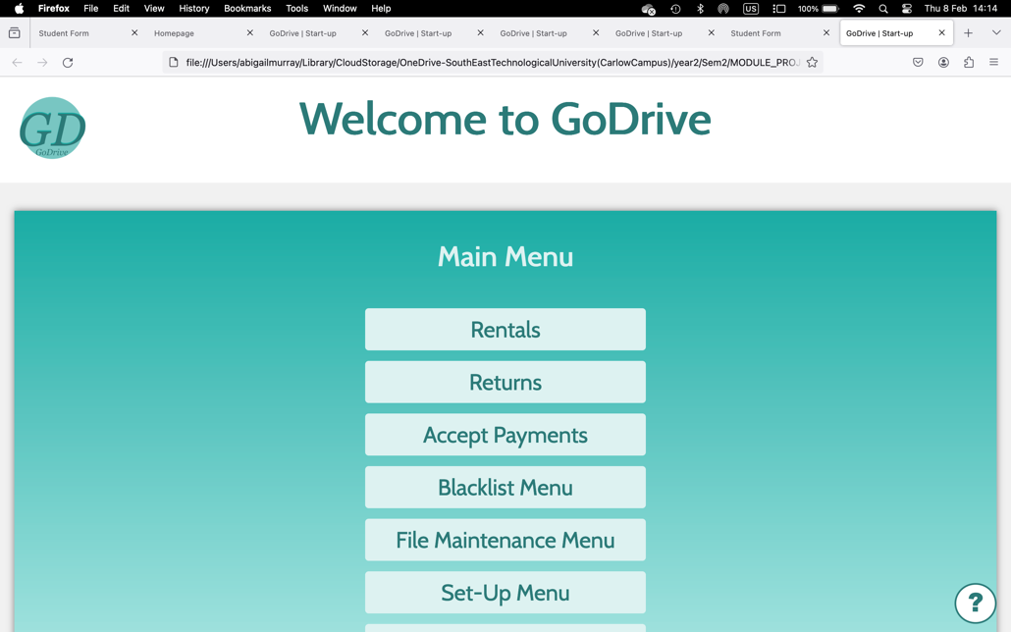For the heading of the menu we picked size 2.5em so that it stands out against the background. The headings are centred in position.

